Would I be Helped? Cross-National CCTV Footage Shows That Intervention Is the Norm in Public Conflicts

Accepted manuscript (published in American Psychologist)*

Richard Philpot
Lancaster University
University of Copenhagen
Lasse S. Liebst
University of Copenhagen
Mark Levine
Lancaster University
University of Exeter
Wim Bernasco
Netherlands Institute for the Study of Crime and Law Enforcement (NSCR)
Vrije Universiteit Amsterdam
Marie R. Lindegaard
Netherlands Institute for the Study of Crime and Law Enforcement (NSCR)
University of Copenhagen

Author Note
Replication data, statistical scripts, and video coding procedures are made available on the Open Science Framework - https://osf.io/xzjsg
Correspondence concerning this article should be addressed to Richard Philpot, Department of Psychology, Lancaster University, Lancaster, LA1 4YF, United Kingdom
E-mail: r.philpot@lancaster.ac.uk
Abstract
Half a century of research on bystander behavior concludes that individuals are less likely to intervene during an emergency when in the presence of others than when alone. By contrast, little is known regarding the aggregated likelihood that at least someone present at an emergency will do something to help. The importance of establishing this aggregated intervention baseline is not only of scholarly interest but is also the most pressing question for actual public victims—will I receive help if needed? The current article describes the largest systematic study of real-life bystander intervention in actual public conflicts captured by surveillance cameras. Using a unique cross-national video dataset from the United Kingdom, the Netherlands, and South Africa (N = 219), we show that in 9 of 10 public conflicts, at least 1 bystander, but typically several, will do something to help. We record similar likelihoods of intervention across the 3 national contexts, which differ greatly in levels of perceived public safety. Finally, we find that increased bystander presence is related to a greater likelihood that someone will intervene. Taken together these findings allay the widespread fear that bystanders rarely intervene to help. We argue that it is time for psychology to change the narrative away from an absence of help and toward a new understanding of what makes intervention successful or unsuccessful.

Keywords: Bystander effect; bystander intervention; aggression and violence; dangerous emergencies; helping and prosocial behavior

* © 2019, American Psychological Association. This paper is not the copy of record and may not exactly replicate the final, authoritative version of the article. Please do not copy or cite without authors' permission. The final article will be available, upon publication, via its DOI: 10.1037/amp0000469
Introduction
How likely is it that a victim of aggression in urban public space receives bystander help? Perspectives from across the social sciences long suggest that the urban experience of living in a mass of strangers dulls our sensitivity to the needs of others, thus giving rise to “norms of noninvolvement” (Milgram, 1970; see also Goffman, 1963). In resonance with this, many can recall media reports in which available bystanders did not assist a victim of a public assault. A particularly renowned case is the 1964 rape and murder of Kitty Genovese, about which the media reported that 38 bystanders watched for half-an-hour without providing help (though note that recent work questions this account; see Manning, Levine, & Collins, 2007). Prompted by this tragic incident, and the subsequent public furor, social psychologists Darley and Latané (1968) set out to explain why those individuals present did not intervene. In a series of highly influential experiments simulating a number of different emergency scenarios, researchers found that additional bystander presence prompted a diffusion of responsibility that constrained individual intervention motivations (Latané & Darley, 1970; Latané & Nida, 1981). This phenomenon, which came to be known as the “bystander effect,” is well replicated and appears in the majority of introductory psychology textbooks (Ferguson, Brown, & Torres, 2018; Fischer et al., 2011).
The knowledge that an individual’s likelihood to intervene reduces in the presence of others does not establish, however, the aggregated likelihood that at least someone will help. From the perspective of the victim this remains the most important question (Latané & Nida, 1981)—will I receive help if needed? The originators of the research tradition were aware of the significance of the distinction (Darley & Latané, 1968) highlighting that: “It is meaningless to compare directly individual with group responses, since . . . there is a purely mechanical potential for getting more help with more people” (Latané, 1981, p. 350). This distinction between responsibility diffusion and mechanical helping potential is an important one but is usually sidestepped in public and scientific discourse (Stalder, 2008). For example, by default, experimental studies and student texts foreground the individual bystander effect with the Kitty Genovese case, which, essentially, is a story of aggregated nonintervention. What remains is a lasting impression that in populated public settings, because of the high number of individuals present, victims will rarely be helped when in need (Lurigio, 2015; Manning et al., 2007).
It is important therefore to recognize a key distinction between the likelihood of individual intervention and the aggregate that at least someone provides help. Yet, in comparison to the vast number of studies that examine intervention from the perspective of the individual bystander, we know surprisingly little about the situational intervention likelihood—that is the probability that at least one bystander at the emergency event intervenes. One possible route to knowledge would be to attempt to establish this baseline through an assessment of the previous experimental work. However, this would say little about public safety in numbers, given that the group conditions of these experiments typically consist of one, and at most a handful, of other bystanders, who are often confederates instructed not to intervene. Furthermore, if interested in intervention rates during aggressive encounters, such as the Kitty Genovese incident, then the experimental literature offers limited insights, given that it is ethically and practically difficult to simulate violent emergencies (Cherry, 1995; Liebst, Heinskou, & Ejbye-Ernst, 2018). Finally, the use of sparsely populated simulation conditions to understand violence intervention raises issues of ecological validity, given that public violent crimes tend to be concentrated in high-density pedestrian areas. For example, a recent bystander victimization study notes that around an average of 16 bystanders are present during public assaults (Liebst et al., 2018).
Outside of experimental work, a few studies have assessed the rate of bystander intervention in real-life violent settings, but with mixed findings. Using official case files of reported assaults, Felson and Steadman (1983) found that a bystander attempted conflict mediation in 10.8% of incidents. A more recent assessment of police-reported case files of public assaults showed that at least one bystander intervened in 73.8% of cases (Heinskou & Liebst, 2017). Alternatively, in-situ observations of bystander actions during barroom assaults recorded that between 26.2% and 39.5% of incidents contained de-escalatory bystander intervention (Parks, Osgood, Felson, Wells, & Graham, 2013; Wells & Graham, 1999). However, official case files and in situ observations are unreliable methods for capturing multiple and intricate bystander interactions occurring during chaotic violent events (Morrison, Lee, Gruenewald, & Mair, 2016; Nassauer & Legewie, 2018). This limitation may explain the large variation between studies and further suggests an underestimation of the intervention rate in previous work.
Video footage is increasingly recognized as the most complete data source for assessing real-life human interactions (Gilmore & Adolph, 2017; Lindegaard & Bernasco, 2018). The recent proliferation of closed-circuit television (CCTV) provides an opportunity to systematically observe real-life emergencies as they occur in their naturalistic settings, yet its use within the bystander field remains surprisingly rare. Levine, Taylor, and Best (2011) pioneered the first systematic behavioral analysis of actual bystander behavior, captured by public surveillance cameras. Coding the frame by frame actions of 228 bystanders across 42 CCTV clips, this work mapped the patterns of bystander actions associated with the escalation and de-escalation of public violence. More recently, Liebst, Heinskou, and Ejbye-Ernst (2018) utilized surveillance footage of police-reported street assaults to establish the likelihood and related risk factors of being victimized when intervening as a third-party. Although novel in their methodological approach and findings, these rare video-based studies did not establish the actual base rate of a victim receiving some form of bystander help.
Therefore, in the present study, we examine bystander intervention rates in 219 naturally occurring aggressive public incidents, captured by surveillance cameras across three national contexts—the Netherlands, the United Kingdom, and South Africa. This sample, which is the largest and first cross-national video corpus of public conflicts assembled, offers a unique opportunity to observe how common bystander intervention into real-life public aggression actually is. With the inclusion of data from the city center of Cape Town, South Africa, we provide an interesting cross-cultural reference category for intervention from a place where perceptions of public safety are significantly lower (Lemanski, 2004; United Nations, 2015). The purpose of the current study is as follows: First, we aim to determine the percentage of real-life conflicts captured by public cameras where at least one bystander intervenes. Second, in an explorative data analysis, we examine whether this intervention likelihood varies across the national contexts that differ in public perceptions of safety. Finally, we assess whether the situational intervention likelihood increases with additional bystander presence. In other words, we aim to answer the often-neglected question of whether the increased number of potential helpers offsets the reduced willingness to help in each of them, a question raised by Darley and Latané (1968; Latané, 1981) but most frequently neglected in the subsequent experimental literature (Stalder, 2008).
Methods
Data and Sample
The data comprised of video surveillance footage of real-life public space conflicts captured by actively monitored surveillance cameras in urban areas of Amsterdam, the Netherlands, Cape Town, South Africa, and Lancaster, the United Kingdom. All public surveillance cameras were located within the inner entertainment areas and central business districts of the cities and typically captured public streets with shopfronts and drinking venues, parks, plazas, pedestrian walkways, and transport station exteriors. Following other surveillance camera studies (Levine et al., 2011; Liebst et al., 2018; Lindegaard et al., 2017), video access was provided under the conditions that data would be securely stored, shared only for legitimate research purposes and not with the wider public, and that the identity of the individuals visible in the footage would be protected (see Philpot, Liebst, Møller, Lindegaard, & Levine, 2019). The research was authorized by the Dutch Ministry of Justice, the municipality City of Cape Town, Lancaster City Council, and was approved by the Ethics Committee for Legal and Criminological Research (CERCO) of the Faculty of Law, Free University Amsterdam, and the Ethics Committee of the Department of Psychology, University of Exeter, the United Kingdom.
All data were recorded by municipality employed camera operatives, who according to identical guidelines were instructed to record all incidents of public space aggression that contained any level of conflict—from the mildest animated disagreements to grave physical violence. This inclusive sampling strategy avoided skewing data toward severe police reported incidents—a known issue in prior video-based crime analyses (Lindegaard & Bernasco, 2018)—and provided a more representative picture of everyday public space conflicts. Recordings were typically taken from the point at which the operative noticed a potential for violence (e.g., postural and gestural displays of anger and aggression, see Dael, Mortillaro, & Scherer, 2012; Levine et al., 2011) to the point when the incident had either naturally dissipated or the police had separated the conflict parties.
The raw sample of video data contained 1,225 clips. From this raw sample, we selected clips that conformed to the following inclusion criteria: The clip was taken from an inner city, urbanized setting. The clip contained a conflict between at least two individuals and did not show another type of incident (e.g., traffic accident, robbery or theft, begging, drug dealing). The police or paramedics were not present when the conflict commenced (see Levine et al., 2011). The clip was not a duplicate and had a technical quality (e.g., resolution, brightness) that allowed for behavioral coding with none, or negligible, breaks in the recorded interaction sequence (see Nassauer & Legewie, 2018; for flowchart of video exclusion criteria and sampling considerations, see supplementary materials at Open Science Framework https://osf.io/xzjsg).
The final video corpus comprised of 219 unique video clips of aggressive incidents captured by actively monitored surveillance cameras in urban areas of the Netherlands (n = 63), South Africa (n = 61), and the United Kingdom (n = 95). After the application of exclusion criteria to the wider corpus, and prior to commencing analysis, we conducted a statistical power analysis to assess whether the sample size of 219 videos would be adequate to detect a small-medium effect size in line with meta-analytical bystander effect evidence (Fischer et al., 2011) and of practical significance (Kirk, 1996). An insufficient sample power could have indicated the need to lower the stringent data inclusion criteria and admit additional videos of lower quality and sequence capture. Several power analysis scenarios indicated that a sample of around 210 videos would detect a small-medium effect size (odds ratio [OR] ~ 1.75), with a power of 95%, and α = .05. We therefore maintained the initial video inclusion criteria and sample size.
Coding Procedure
The 219 videos were coded by four trained research assistants in accordance with a systematic and interrater reliability tested codebook (for the full Observational Codebook containing detailed descriptions of all study variables, see supplementary materials at https://osf.io/xzjsg). Coding began by identifying the emergency conflict parties—the two individuals between whom the encounter initially manifested itself. Because we were interested solely in baseline levels of intervention (irrespective of personal or group properties of the bystander), all other individuals present in the situation were defined as bystanders.
In experimental bystander literature, intervention acts are defined from the specifics of the simulation—for example, in a setup where a handful of pencils or coins are “accidentally” dropped, intervention is operationalized accordingly as helping to pick them up (Latané, 1981). In the current study, intervention is similarly defined from the affordance of the emergency at hand—in this case, real-life conflicts that require the bystander to act toward a perpetrator or victim in a manner that may soothe the conflict. Therefore, to code bystander helping acts we applied standardized behavioral definitions of intervention, as recently developed through video observational bystander research (Levine et al., 2011; Liebst et al., 2018; Lindegaard et al., 2017). Specifically, a bystander was determined as an intervener if they attempted to placate the conflict with any of the following acts: pacifying gesturing; calming touches; blocking contact between conflict parties (Figure 1c); holding, pushing or pulling an aggressor away from the conflict (Figure 1c); consoling a victim of aggression; providing practical help to a physically harmed victim (for the full Observational Codebook containing detailed descriptions of all study variables, see supplementary materials at https://osf.io/xzjsg).
—— INSERT FIGURE 1 HERE ——
For each clip, coders recorded the total number of interveners. This provided descriptive detail regarding the sum of interveners per context and allowed for the assessment of situational bystander intervention. In addition, coders noted the total number of bystanders at an event (M = 16.29, SD = 13.16), the duration of the conflict (M = 3.27 minutes, SD = 4.20), and the national context of each clip. To test the reliability of the coded variables, we randomly selected 24 videos (11% of the total sample) for double coding (see Riffe, Lacy & Fico, 2014). Both rater-observed variables included in the analyses (the number of attentive bystanders present and the number of interveners) reached Krippendorff’s alpha values of α = .85 and .87, respectively, indicating high levels of interrater reliability (De Swert, 2012; Krippendorff, 2004) (for further information, see supplementary materials at https://osf.io/xzjsg). Disagreements between coders were resolved by randomly selecting one coder’s response.
Results
We first descriptively examined the situational baseline of bystander intervention across all 219 CCTV clips. We found that at least one bystander intervened in 90.9% of the situations, with an average of 3.76 interveners per video (SD = 3.01). Next, using a Firth penalized likelihood logit analysis, we assessed whether these intervention likelihoods varied across national contexts while controlling for the duration of the conflict. With this model, we further assessed whether the situational intervention likelihood increased with additional bystander presence.
We did not find evidence of a significant difference in the likelihood that at least one bystander intervenes when comparing the Netherlands (OR = 0.61, 95% confidence interval [CI] [0.19, 1.94], p = .41) and the United Kingdom (OR = 1.59, 95% CI [0.51, 4.91], p = .42) to the South African reference category (Figure 2) (for full regression outputs, see supplementary materials at Open Science Framework https://osf.io/xzjsg). To further assess whether data offers evidence in favor of a non-association, we used Bayesian information criteria (BIC) to calculate Bayes factors (see Dienes, 2014) to compare the relative evidence between models excluding and including national contexts—note, a benefit of BIC-approximated Bayes factors is that they do not require the specification of priors (see Wagenmakers, 2007). An estimated Bayes factor (BF₀₁ = 17.27) indicated evidence in favor of a non-association between national context and intervention.
—— INSERT FIGURE 2 HERE ——
The number of bystanders at an event was positively associated with the situational likelihood of intervention (OR = 1.10, 95% CI [1.03, 1.18], p = .008, BF₀₁ = 0.03), with each additional bystander increasing the odds that a victim receives help by factor 1.1 (Figure 2). When assessed in a standardized effect size metric (see Gelman, 2008), the number of bystanders is a very strong (Rosenthal, 1996) predictor of situational intervention (OR = 12.72, 95% CI [1.96, 82.50], p = .008, BF₀₁ = 0.03), though the broad confidence interval leaves uncertainty regarding the precision of this estimate.
Discussion
Decades of social scientific research has been concerned with the issue of bystander apathy and lack of safety in numbers during public emergency events, with the bystander effect hypothesis the epicenter of these discussions. This hypothesis is an example of the way in which a scholarly theory can come to be adopted by the public as a “lay concept” (Giddens, 1984) to understand incidents where no-one intervened when required (Lurigio, 2015; Manning et al., 2007). Without careful interpretation of the findings, the individual likelihood of intervention and the aggregate likelihood that at least someone intervenes become conflated, and may provide an easily misleading answer to the public’s key question: Will I be helped if victimized in public? In 50 years of bystander research, little has been done to answer this question (Stalder, 2008), meaning we still do not know what the aggregate likelihood is that a victim of public aggression will receive some help.
In an effort to establish a veridical and ecologically valid baseline of intervention in actual public conflicts, we systematically observed real-life bystander behavior captured by public surveillance footage from three national contexts. We found that in nine-out-of-ten conflicts at least one person—but typically several—did something to help. These findings challenge established assumptions that urban living (Milgram, 1970), and certain neighborhood contexts (Sampson, Raudenbush, & Earls, 1997), undermine social responsibility and the related willingness to intervene into public violence. Therefore, in contrast to the notion that noninvolvement is the norm in urban environments, the high levels of intervention found in this study across different national and urban contexts suggests that involvement is the norm in real-life inner-city public conflicts.
Initially, the high rate of intervention found in this study may be surprising, as the bystanders are entering real-life conflicts with some risk of victimization (see Liebst et al., 2018) that may deter involvement. On the other hand, this willingness to intervene is in line with behavioral economic evidence from public-good experiments demonstrating that third-parties frequently engage in personally costly behaviors to punish norm-violating individuals and to preserve social norms (Fehr & Fischbacher, 2004; Fehr & Gächter, 2002; Gächter, 2014). The overall high level of intervention is also consistent with experimental bystander research showing that individuals are likely to respond to dangerous (although not actually violent) emergencies, even at an individual cost (Fischer, Greitemeyer, Pollozek, & Frey, 2006; Harari, Harari, & White, 1985; for review, see Fischer et al., 2011). Here, perceptions of victim distress may motivate bystanders to help as a direct means to relieve the victim’s suffering (Batson, 2011) or to alleviate their own unpleasant arousal from witnessing the emergency (Cialdini et al., 1987; Piliavin, Dovidio, Gaertner, & Clark III, 1981). More broadly, this underlying propensity for empathy with others and third-party peacekeeping behavior is argued to be central for the maintenance of cooperative societal living (de Waal, 2007; Verbeek & Peters, 2018).
It is further surprising that the magnitude of the intervention rates does not vary between the three national-city contexts, given that inner-city Cape Town, South Africa has comparatively lower perceptions of public safety (Lemanski, 2004; United Nations, 2015) that may elicit significantly less intervention (because of personal risk aversion) or more intervention (because of greater perceived victim need). The non-association evidenced in this study would indicate that it is not the level of perceived danger that sets the overall rate of intervention. Instead it appears that any sign of danger is perceived as a signal which prompts the importance or imperative of intervention. This is assumption is in line with meta-analytical evidence that bystander apathy decreases when the situation is perceived as dangerous (Fischer et al., 2011). The consistent intervention rate found across the disparate national cities also supports anthropological work suggesting that third-party conflict resolution is a human universal (Brown, 1991), with a plausible evolutionary basis, as reflected by the abundance of peacekeeping practices among our closest nonhuman primate kin (Boehm, 2000; de Waal, 2000).
An often-neglected question in bystander research is whether a low individual likelihood to intervene can go hand-in-hand with a high aggregate level of intervention (Stalder, 2008). It is important that by examining intervention on the situational rather than the individual level, our research does not evaluate whether bystanders are less likely to provide help when in the presence of other bystanders compared with when they are alone (i.e., the bystander effect). Our results do suggest, however, that with increasing numbers of bystanders, the greater the likelihood it is that at least someone will intervene to help. It is important to recognize that a positive association between bystander numbers and the likelihood of receiving help has been established before. Specifically, Stalder (2008) reanalyzed previous meta-analytical work (Latané & Nida, 1981) and found a positive correlation between group size and help provision under conditions in which bystanders were separated, yet knew of one another’s presence. The current study adds to this account with evidence from systematic obsevations of real-life public space emergencies.
The immediate theoretical implication of these accumulating bodies of evidence is that bystander research should distinguish between responsibility diffusion and mechanical helping potential that may operate inversely on the individual and situational levels, respectively—in other words, while additional numbers may reduce the individual helping propensity, it can provide a larger pool from which help-givers may be sourced. The finding that help is more likely given in populated settings also has several societal implications. First, it informs current debates within criminology regarding whether populated settings provide a safety in numbers, or alternatively, facilitates violent events (Hillier, 2004; Summers & Johnson, 2017). Our data supports a rapprochement between these views: While the copresence of more people may increase the opportunities for conflictual interactions, additional numbers conjointly offer more opportunities for bystander intervention. Second, this latter point offers an alternative picture to the common public association between the “unknown other” and “stranger danger” (Hale, 1996; Jackson & Gouseti, 2016). Finally, for policing strategies, our results indicate that groups are willing to “self-police” (Reicher et al., 2007) conflicts, and as such, bystanders are an unharnessed crime preventive resource for informally regulating violence prior to the arrival of the police.
The bystander effect paradigm, like other research pillars of the social sciences (Mortensen & Cialdini, 2010), was prompted by a naturally occurring atrocity (e.g., the Kitty Genovese case). Subsequent bystander work, however, has almost exclusively been conducted in sparsely populated experimental setups, simulating trivial events with little potential danger or negative costs for the intervener (for critique, see Fischer et al., 2006). The incongruence between real-life aggressive public assaults and simulations risks creating a body of knowledge ill-equipped to explain the real-life bystander phenomenon that initially prompted such research (see Cialdini’s “Full Cycle Psychology” (1980; Mortensen & Cialdini, 2010)—see also, Swann & Jetten, 2017). The current article offers a methodological corrective by systematically observing bystander behavior in dangerous, populated, naturalistic settings captured by video footage. By observing the real-world phenomenon, the low ecological validity of the experimental bystander work becomes more apparent. First, emergencies in public spaces can be dangerous. Second, people in urban spaces are rarely alone or solely in the company of one-or-two others, as frequently simulated in experimental work. Today, with the increased availability of high-quality video recordings of actual emergencies there are new opportunities for the study of human violence and pro-social behavior in real-life settings (Gilmore & Adolph, 2017; Lindegaard & Bernasco, 2018). While the current study assessed intervention as a situational aggregate, future video studies should prioritize the inclusion of individual-level predictors of helping, known to influence intervention. For example, evidence shows that gender roles may shape expressions of helping behavior (Eagly, 2009), while other studies report a robust association between shared group membership and the likelihood of help provision (Levine & Manning, 2013; Lindegaard et al., 2017; Slater et al., 2013).
The current study has limitations that warrant discussion. In light of the very high intervention rate reported, also in comparison to prior research (e.g., Felson & Steadman, 1983), we consider factors that may have inflated our intervention figure. First, it could be argued that we deployed an overinclusive behavioral definition of bystander intervention, for example, at a minimum, a calming open-handed gesture toward a perpetrator or consoling a victim of aggression (for further discussion around the theoretical justification of including consolation in the intervention measure, see supplementary materials at https://osf.io/xzjsg). However, this may be balanced by the fact that all videos lacked sound, and thus did not allow for the coding of verbal interventions, such as spoken pleas to “calm down” or warnings that “I’m calling the police.” Furthermore, the current paper did not code aggressive bystander interventions, which may at times be used as a means to de-escalate conflict (Stott, Hutchison, & Drury, 2001).
A second limitation of the current data is the sampling skewness toward inner-city areas with a high density of restaurants, bars, and discotheques. As such, it is plausible that a proportion of bystanders consumed alcohol that may have affected their risk assessment (Weafer & Fillmore, 2016). This inner-city restriction on the data selection strategy meant that we did not capture violence intervention rates in the encompassing areas, which particularly in the South African case might provide different results because surrounding disadvantaged areas (referred to as townships) have disproportionally higher levels of public crime (South African Police Service, 2018). Furthermore, our inner-city data bias means that we do not have comparative data of intervention in other public spaces, including conflicts at music and sporting events, or sexual aggression on campuses (Banyard, 2015; Stott, Adang, Livingstone, & Schreiber, 2007). As a result, we are not able to say very much about the extent to which the bystander intervention likelihood varies across wider social contexts.
A final methodological limitation of our analytical strategy is that it is nonexperimental, and therefore lacks the counterfactual evidence for drawing the strongest conclusions about the relations between bystander intervention, group size, and national contexts. Although our correlational design cannot provide the most rigorous evidence of causality, its external validity is unparalleled.
According to conventional wisdom, there is an epidemic of bystander noninvolvement during public emergencies. Challenging this view, the current cross-national study of video data shows that intervention is the norm in actual aggressive conflicts, with more populated settings providing a greater likelihood that someone helps. This is reassuring for potential victims of violence, the public as a whole, and may inform crime preventive efforts to make use of the already very active bystanders. Given these societal implications, we believe it is critical that future bystander research and its public dissemination flag the often-neglected distinction between the bystander effect and the simple mechanic of getting more help with more people. In shifting the perspective from an absence of help to an almost ever-presence, we leave behind the question of “why don’t individuals help?” and explore a new avenue of enquiry asking: “what makes intervention successful?”

References
Banyard, V. L. (2015). Toward the next generation of bystander prevention of sexual and relationship violence: Action coils to engage communities. London: Springer.
Batson, C. D. (2011). Altruism in humans. Oxford: Oxford University Press.
Boehm, C. (2000). Conflict and the evolution of social control. Journal of Consciousness Studies, 7(1-2), 79-101.
Brown, D. E. (1991). Human universals. New York: McGraw-Hill.
Cherry, F. (1995). The 'stubborn particulars' of social psychology: Essays on the research process. London: Routledge.
Cialdini, R. B. (1980). Full-cycle social psychology. Applied Social Psychology Annual, 1, 21-47.
Cialdini, R. B., Schaller, M., Houlihan, D., Arps, K., Fultz, J., & Beaman, A. L. (1987). Empathy-based helping: Is it selflessly or selfishly motivated? Journal of Personality and Social Psychology, 52(4), 749. doi.org/10.1037/0022-3514.52.4.749
Dael, N., Mortillaro, M., & Scherer, K. R. (2012). Emotion expression in body action and posture. Emotion, 12(5), 1085-1101. doi.org/10.1037/a0025737
Darley, J. M., & Latané, B. (1968). Bystander intervention in emergencies: Diffusion of responsibility. Journal of Personality and Social Psychology, 8(4), 377-383. doi:10.1037/h0025589
De Swert, K. (2012). Calculating inter-coder reliability in media content analysis using Krippendorff's Alpha. Retrieved from https://www.polcomm.org/wp-content/uploads/ICR01022012.pdf
de Waal, F. B. M. (2000). Primates - a natural heritage of conflict resolution. Science, 289(5479), 586-590. doi:10.1126/science.289.5479.586
de Waal, F. B. M. (2007). The "Russian doll" model of empathy and imitation. In S. Bråten (Ed.), On being moved: From mirror neurons to empathy (pp. 49–69). Amsterdam: Benjamins.
Dienes, Z. (2014). Using Bayes to get the most out of non-significant results. Frontiers in Psychology, 5(781), 1-17. doi:10.3389/fpsyg.2014.00781
Eagly, A. H. (2009). The his and hers of prosocial behavior: An examination of the social psychology of gender. American Psychologist, 64(8), 644-658. doi:10.1037/0003-066X.64.8.644
Fehr, E., & Fischbacher, U. (2004). Third-party punishment and social norms. Evolution and Human Behavior, 25(2), 63-87. doi.org/10.1016/S1090-5138(04)00005-4
Fehr, E., & Gächter, S. (2002). Altruistic punishment in humans. Nature, 415(6868), 137-140. doi.org/10.1038/415137a
Felson, R. B., & Steadman, H. J. (1983). Situational factors in disputes leading to criminal violence. Criminology, 21(1), 59-74. doi:10.1111/j.1745-9125.1983.tb00251.x
Ferguson, C. J., Brown, J. M., & Torres, A. V. (2018). Education or indoctrination? The accuracy of introductory psychology textbooks in covering controversial topics and urban legends about psychology. Current Psychology, 37, 574-582. doi:10.1007/s12144-016-9539-7
Fischer, P., Greitemeyer, T., Pollozek, F., & Frey, D. (2006). The unresponsive bystander: Are bystanders more responsive in dangerous emergencies? European Journal of Social Psychology, 36(2), 267-278. doi:10.1002/ejsp.297
Fischer, P., Krueger, J. I., Greitemeyer, T., Vogrincic, C., Kastenmüller, A., Frey, D., . . . Kainbacher, M. (2011). The bystander-effect: A meta-analytic review on bystander intervention in dangerous and non-dangerous emergencies. Psychological Bulletin, 137(4), 517-537. doi:10.1080/00224545.2012.697931
Gächter, S. (2014). Human pro-social motivation and the maintenance of social order. In E. Zamir & D. Teichman (Eds.), The Oxford Handbook of Behavioral Economics and the Law (pp. 28-60). Oxford: Oxford University Press.
Gelman, A. (2008). Scaling regression inputs by dividing by two standard deviations. Statistics in Medicine, 27(15), 2865-2873. doi:10.1002/sim.3107
Giddens, A. (1984). The constitution of society: Outline of the theory of structuration: CA: University of California Press.
Gilmore, R. O., & Adolph, K. E. (2017). Video can make behavioural science more reproducible. Nature Human Behavior, 1(7). doi:10.1038/s41562-017-0128
Goffman, E. (1963). Behavior in public places: Notes on the social organization of gatherings. New York: Free Press of Glencoe.
Hale, C. (1996). Fear of crime: A review of the literature. International Review of Victimology, 4(2), 79-150. doi.org/10.1177/026975809600400201
Harari, H., Harari, O., & White, R. V. (1985). The reaction to rape by American male bystanders. The Journal of Social Psychology, 125(5), 653-658. doi:10.1080/00224545.1985.9712039
Heinskou, M. B., & Liebst, L. S. (2017). Gadevold. En sociologisk kortlægning af vold i byen. København: Djøf Forlag.
Hillier, B. (2004). Can streets be made safe? Urban Design International, 9(1), 31-45. doi.org/10.1057/palgrave.udi.9000079
Jackson, J., & Gouseti, I. (2016). Threatened by violence: Affective and cognitive reactions to violent victimization. Journal of Interpersonal Violence, 31(18), 2987-3016. doi:10.1177/0886260515584336
Kirk, R. E. (1996). Practical significance: A concept whose time has come. Educational and Psychological Measurement, 56(5), 746-759. doi:doi.org/10.1177/0013164496056005002
Krippendorff, K. (2004). Reliability in Content Analysis. Human Communication Research, 30(3), 411-433. doi:10.1111/j.1468-2958.2004.tb00738.x
Latané, B. (1981). The psychology of social impact. American Psychologist, 36(4), 343-356. doi:10.1037/0003-066X.36.4.343
Latané, B., & Darley, J. M. (1970). The unresponsive bystander: Why doesn't he help? New York: Appleton-Century-Crofts.
Latané, B., & Nida, S. (1981). Ten years of research on group size and helping. Psychological Bulletin, 89(2), 308-324. doi:10.1037/0033-2909.89.2.308
Levine, M., & Manning, R. (2013). Social identity, group processes, and helping in emergencies. European Review of Social Psychology, 24(1), 225-251. doi:10.1080/10463283.2014.892318
Lemanski, C. (2004). A new apartheid? The spatial implications of fear of crime in Cape
Town, South Africa. Environment and Urbanization, 16(2), 101-112. doi.org/10.1177/095624780401600201
Levine, M., Taylor, P. J., & Best, R. (2011). Third parties, violence, and conflict resolution: The role of group size and collective action in the microregulation of violence. Psychological Science, 22(3), 406-412. doi:10.1177/0956797611398495
Liebst, L. S., Heinskou, M. B., & Ejbye-Ernst, P. (2018). On the actual risk of bystander intervention: A statistical study based on naturally occurring violent emergencies. Journal of Research in Crime and Delinquency, 55(1), 27-50. doi:10.1177/0022427817710776
Lindegaard, M. R., & Bernasco, W. (2018). Lessons learned from crime caught on camera. Journal of Research in Crime and Delinquency, 55(1), 155-186. doi:10.1177/0022427817727830
Lindegaard, M. R., Liebst, L. S., Bernasco, W., Heinskou, M. B., Philpot, R., Levine, M., & Verbeek, P. (2017). Consolation in the aftermath of robberies resembles post-aggression consolation in chimpanzees. PloS one, 12(5), e0177725. doi:10.1371/journal.pone.0177725
Lurigio, A. J. (2015). Crime narratives, dramatizations, and the legacy of the Kitty Genovese murder: A half century of half truths. Criminal Justice and Behavior, 42(7), 782-789. doi:10.1177/0093854814562954
Manning, R., Levine, M., & Collins, A. (2007). The Kitty Genovese murder and the social psychology of helping: The parable of the 38 witnesses. American Psychologist, 62(6), 555-562. doi:10.1037/0003-066X.62.6.555
Milgram, S. (1970). The experience of living in cities. Science, 167(3924), 1461-1468.
Morrison, C., Lee, J. P., Gruenewald, P. J., & Mair, C. (2016). The reliability of naturalistic observations of social, physical and economic environments of bars. Addiction Research & Theory, 24(4), 330-340. doi:10.3109/16066359.2016.1145674
Mortensen, C. R., & Cialdini, R. B. (2010). Full‐cycle social psychology for theory and application. Social and Personality Psychology Compass, 4(1), 53-63. doi:10.1111/j.1751-9004.2009.00239.x
Nassauer, A., & Legewie, N. (2018). Video data analysis: A methodological frame for a novel research trend. Sociological Methods & Research, 1-40. doi:10.1177/0049124118769093
Parks, M. J., Osgood, D. W., Felson, R. B., Wells, S., & Graham, K. (2013). Third party involvement in barroom conflicts. Aggressive Behavior, 39(4), 257-268. doi:10.1002/ab.21475
Philpot, R., Liebst, L. S., Møller, K. K., Lindegaard, M. R., & Levine, M. (2019). Capturing violence in the night-time economy: A review of established and emerging methodologies. Aggression and Violent Behavior. 46, 56-65. doi.org/10.1016/j.avb.2019.02.004
Piliavin, J. A., Dovidio, J. F., Gaertner, S. L., & Clark III, R. D. (1981). Emergency intervention. New York: Academic Press.
Reicher, S., Stott, C., Drury, J., Adang, O., Cronin, P., & Livingstone, A. (2007). Knowledge-based public order policing: Principles and practice. Policing: A Journal of Policy and Practice, 1(4), 403-415. doi.org/10.1093/police/pam067
Riffe, D., Lacy, S., & Fico, F. (2014). Analyzing media message: Using quantiative content analysis in research. London: Routledge.
Rosenthal, J. A. (1996). Qualitative descriptors of strength of association and effect size. Journal of Social Service Research, 21(4), 37-59. doi:10.1300/J079v21n04_02
Sampson, R. J., Raudenbush, S. W., & Earls, F. (1997). Neighborhoods and violent crime: A multilevel study of collective efficacy. Science, 277(5328), 918-924. doi:10.1126/science.277.5328.918
Slater, M., Rovira, A., Southern, R., Swapp, D., Zhang, J. J., Campbell, C., & Levine, M. (2013). Bystander responses to a violent incident in an immersive virtual environment. PLOS ONE, 8, e52766. doi:10.1371/journal.pone.0052766
South Africa Police Service (2018). Crime Statistics 2017/2018. Pretoria: SAPS Head Office.
Retrieved from https://www.saps.gov.za/services/crimestats.php
Stalder, D. R. (2008). Revisiting the issue of safety in numbers: The likelihood of receiving help from a group. Social Influence, 3(1), 24-33. doi:10.1080/15534510701766181
Stott, C., Adang, O., Livingstone, A., & Schreiber, M. (2007). Variability in the collective behaviour of England fans at Euro 2004: ‘Hooliganism’, public order policing and social change. European Journal of Social Psychology, 37, 75–100. doi.org/10.1002/ejsp.338
Stott, C., Hutchison, P., & Drury, J. (2001). ‘Hooligans’ abroad? Inter‐group dynamics, social identity and participation in collective ‘disorder’at the 1998 World Cup Finals. British Journal of Social Psychology, 40(3), 359-384. doi.org/10.1348/014466601164876
Summers, L., & Johnson, S. D. (2017). Does the configuration of the street network influence where outdoor serious violence takes place? Using space syntax to test crime pattern theory. Journal of Quantitative Criminology, 33(2), 397-420. doi:10.1007/s10940-016-9306-9
Swann, W. B. J., & Jetten, J. (2017). Restoring agency to the human actor. Perspectives on Psychological Science, 12(3), 382-399. doi:10.1177/1745691616679464
United Nations (2015). Human development report: Work for human development. New
York: United Nations Development Programme. Retrieved from https://www.compassion.com/multimedia/human-development-report-2015-undp.pdf
Verbeek, P., & Peters, B. A. (2018). The nature of peace. In P. Verbeek & B. A. Peters (Eds.), Peace ethology: Behavioral processes and systems of peace (pp. 1-13). Hoboken, New Jersey: Wiley & Sons Ltd.
Wagenmakers, E.-J. (2007). A practical solution to the pervasive problems of p values. Psychonomic Bulletin & Review, 14(5), 779-804. doi:10.3758/BF03194105
Weafer, J., & Fillmore, M. T. (2016). Low-dose alcohol effects on measures of inhibitory control, delay discounting, and risk-taking. Current Addiction Reports, 3(1), 75-84. doi:10.1007/s40429-016-0086-y
Wells, S., & Graham, K. (1999). The frequency of third-party involvement in incidents of barroom aggression. Contemporary Drug Problems, 26(3), 457-480. doi:10.1177/009145099902600306

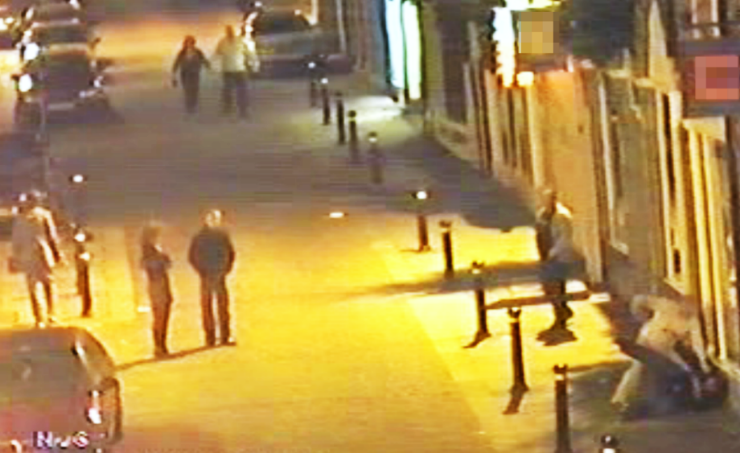
Figure 1a. On the bottom right-hand side, a man dressed in a white shirt assaults another man who is on the ground. Some bystanders observe.

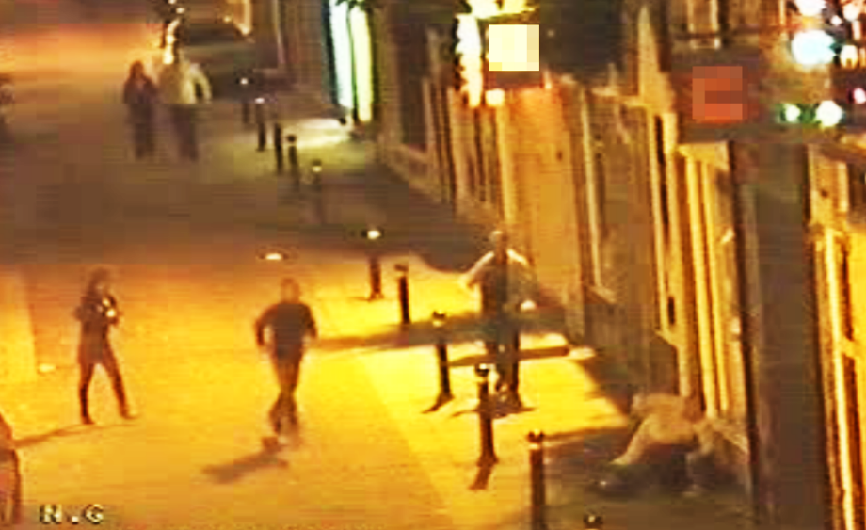
Figure 1b. To the bottom left-hand side, two bystanders leave their standing positions and approach the conflict parties.

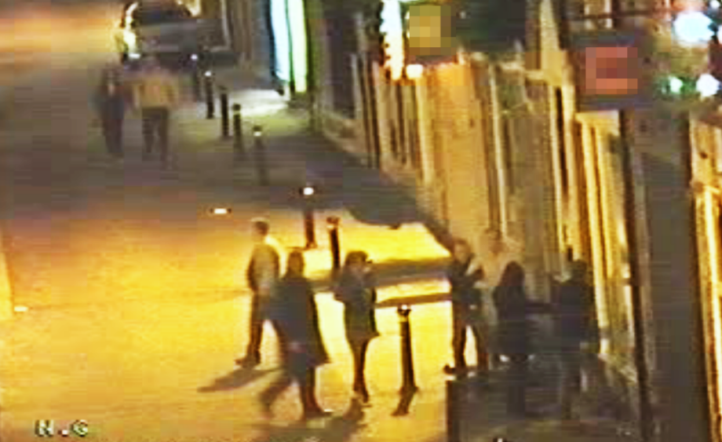
Figure 1c. The two bystanders are joined by others. A male bystander in a dark shirt and jeans pulls the main aggressor from his target, while a female bystander steps between the conflict parties and extends both arms out in a blocking motion.

Figure 2. Estimates (odds ratio) coefficients and 95% confidence intervals. Firth logistic regression model, N = 219, including control for conflict duration (estimate not shown in figure).

* © 2019, American Psychological Association. This paper is not the copy of record and may not exactly replicate the final, authoritative version of the article. Please do not copy or cite without authors' permission. The final article will be available, upon publication, via its DOI: 10.1037/amp0000469

On the request of an anonymous reviewer, we assessed the extent to which consolatory acts may have overinflated the intervention figure. To this end, we examined whether consolation was the ONLY bystander intervention performed in a random subsample of 85 videos (38.9% of all data). We found that 1 out of 85 cases contained consolation without any prior bystander intervention act. As such, the inclusion of consolation in the intervention measurement is likely to have negligible impact on the overall findings.

